Blue Room May 2021

Sun | Mon | Tue | Wed | Thu | Fri | Sat
2 | 3 | 4 | 5 | 6 | 7 | 8
May  Flowers for Mom’s | Flower Wreath | Handprint Flower | Color a Flower Garden | Create a Paper Flower Bouquet | Tissue Paper Flower
9 | 10 | 11 | 12 | 13 | 14 | 15
Happy Mother’s Day  Spring Is In The Air | Handprint Baby Bird Nest | Tissue Paper Spring Tree | Decorate A Kite | Color A Bird | Create A Birds Nest
16 | 17 | 18 | 19 | 20 | 21 | 22
On The Farm | Muddy  Pig | Build a Tractor | Fingerprint Sheep | Cow Handprint | Paper Plate chicken | 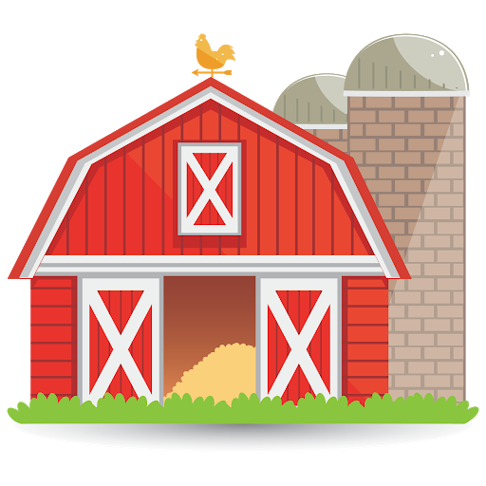
23 | 24 | 25 | 26 | 27 | 28 | 29
Happy Campers | Foil Paint a campfire | In a  tent | Last CLC Culver’s Night  5-8pm  Make a Paper S’more | Make & Decorate a Camper | Lantern Suncatcher
30 | 31
 | CLC Closed for Memorial Day

